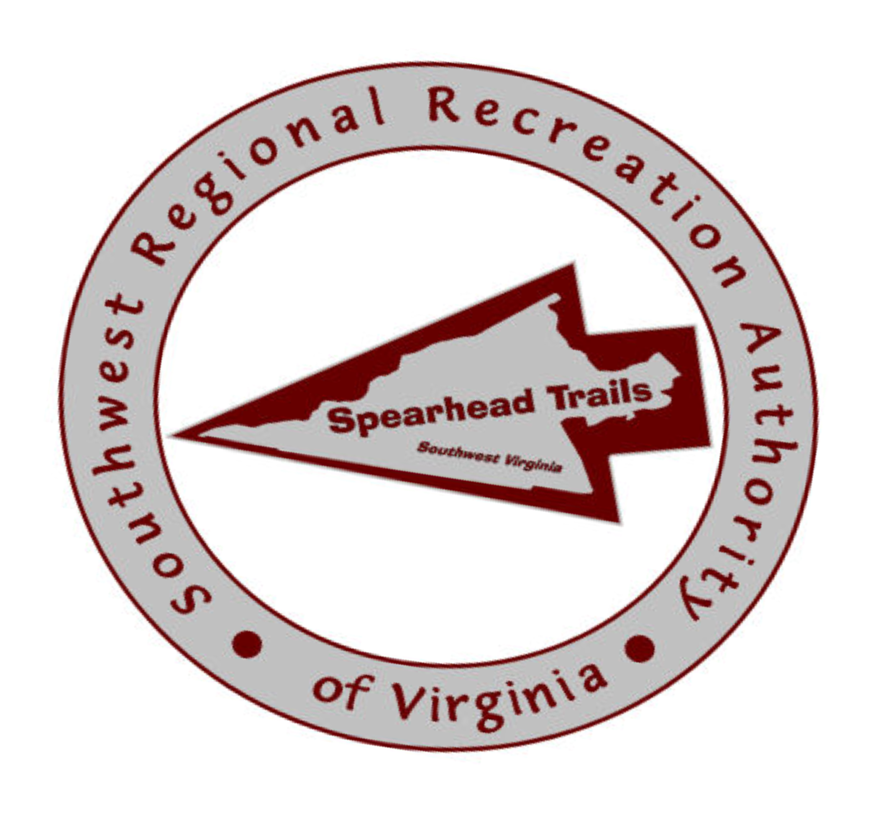
PRESS RELEASE

FOR IMMEDIATE RELEASE
November 12th 2009

Contact:
Mark Caruso, Vice Chairman of SRRA, P.O. Box 297, Norton VA 24273 PH 276-679-1617 mcaruso@nortonva.gov
Debby Spencer, WMTH Corporation, P.O. Box 51153, Bowling Green KY 42102 PH 270-792-5300 spencerdebby@aol.com

SPEARHEAD TRAILS INITIATIVE TO BRING HUNDREDS OF JOBS
AND MILLIONS OF DOLLARS TO SOUTHWEST VIRGINIA

On Thursday morning, the results of a recent five month comprehensive study was presented at a conference held in Norton Virginia that shows that there is tremendous potential for Southwest Virginia to become a “Trail Destination” for ATV riders, bikers, hikers, canoeists, horseback riders, naturalists and others.

The in-depth study and comprehensive plan by We Make Things Happen Corporation (WMTH) was presented at a conference attended by area legislators, county administrators, mayors, and community leaders “We are excited to learn the potential positive impact of the proposed Spearhead Trails system”, notes Jack McClanahan, SRRA Chair.

The study goes on to say that if developed under the guidance of the Southwest Regional Recreation Authority (SRRA), the proposed Spearhead Trail System has the potential to bring 200,000 visitors to the region and adding an additional $30 million to local economies at a time when economic growth is desperately needed. The potential increase in the work force could be as high as 300 to 500 jobs within the next 10 years. “The study will be of great benefit as we approach the Commonwealth of Virginia and other potential funding sources for the funds we will need to start and sustain the project during the development years”, notes Mark Caruso, SRRA Vice Chair. The full report is available in its entirety by calling (270)781-6858 or e-mailing us at spearhead@trailsrus.com.

The Southwest Regional Recreation Authority was created by the Virginia General Assembly in 2008 for the purpose and goal to oversee the development and management of the Spearhead Trail System within the counties of Buchanan, Dickenson, Lee, Russell, Scott, Tazewell, Wise and the City of Norton. The proposed trail system, under the guidance of SRRA, is anticipated to provide economic diversification for the region through the development and expansion of businesses such as outfitters; campgrounds, hotels, B&B’s, and cabin rentals; restaurants; gift shops; supplier stores; shuttle services, etc.

The Spearhead Trails project was started and initially facilitated by Virginia Tourism Corporation’s Partnership Alliance Marketing division, and in 2009 received funding from the Virginia Tobacco Indemnification and Revitalization Commission and the Motorcycle Industry Council to conduct a study to determine the potential and to develop a plan. Additional funding has been received from the City of Norton, the Town of Pennington Gap, the Mountainview ATV Club and the counties of Tazewell, Dickenson, Wise and Buchanan. For more information on the Southwest Regional Recreation Authority (SRRA) and the Spearhead Trails initiative, visit the www.spearheadtrails.com website.

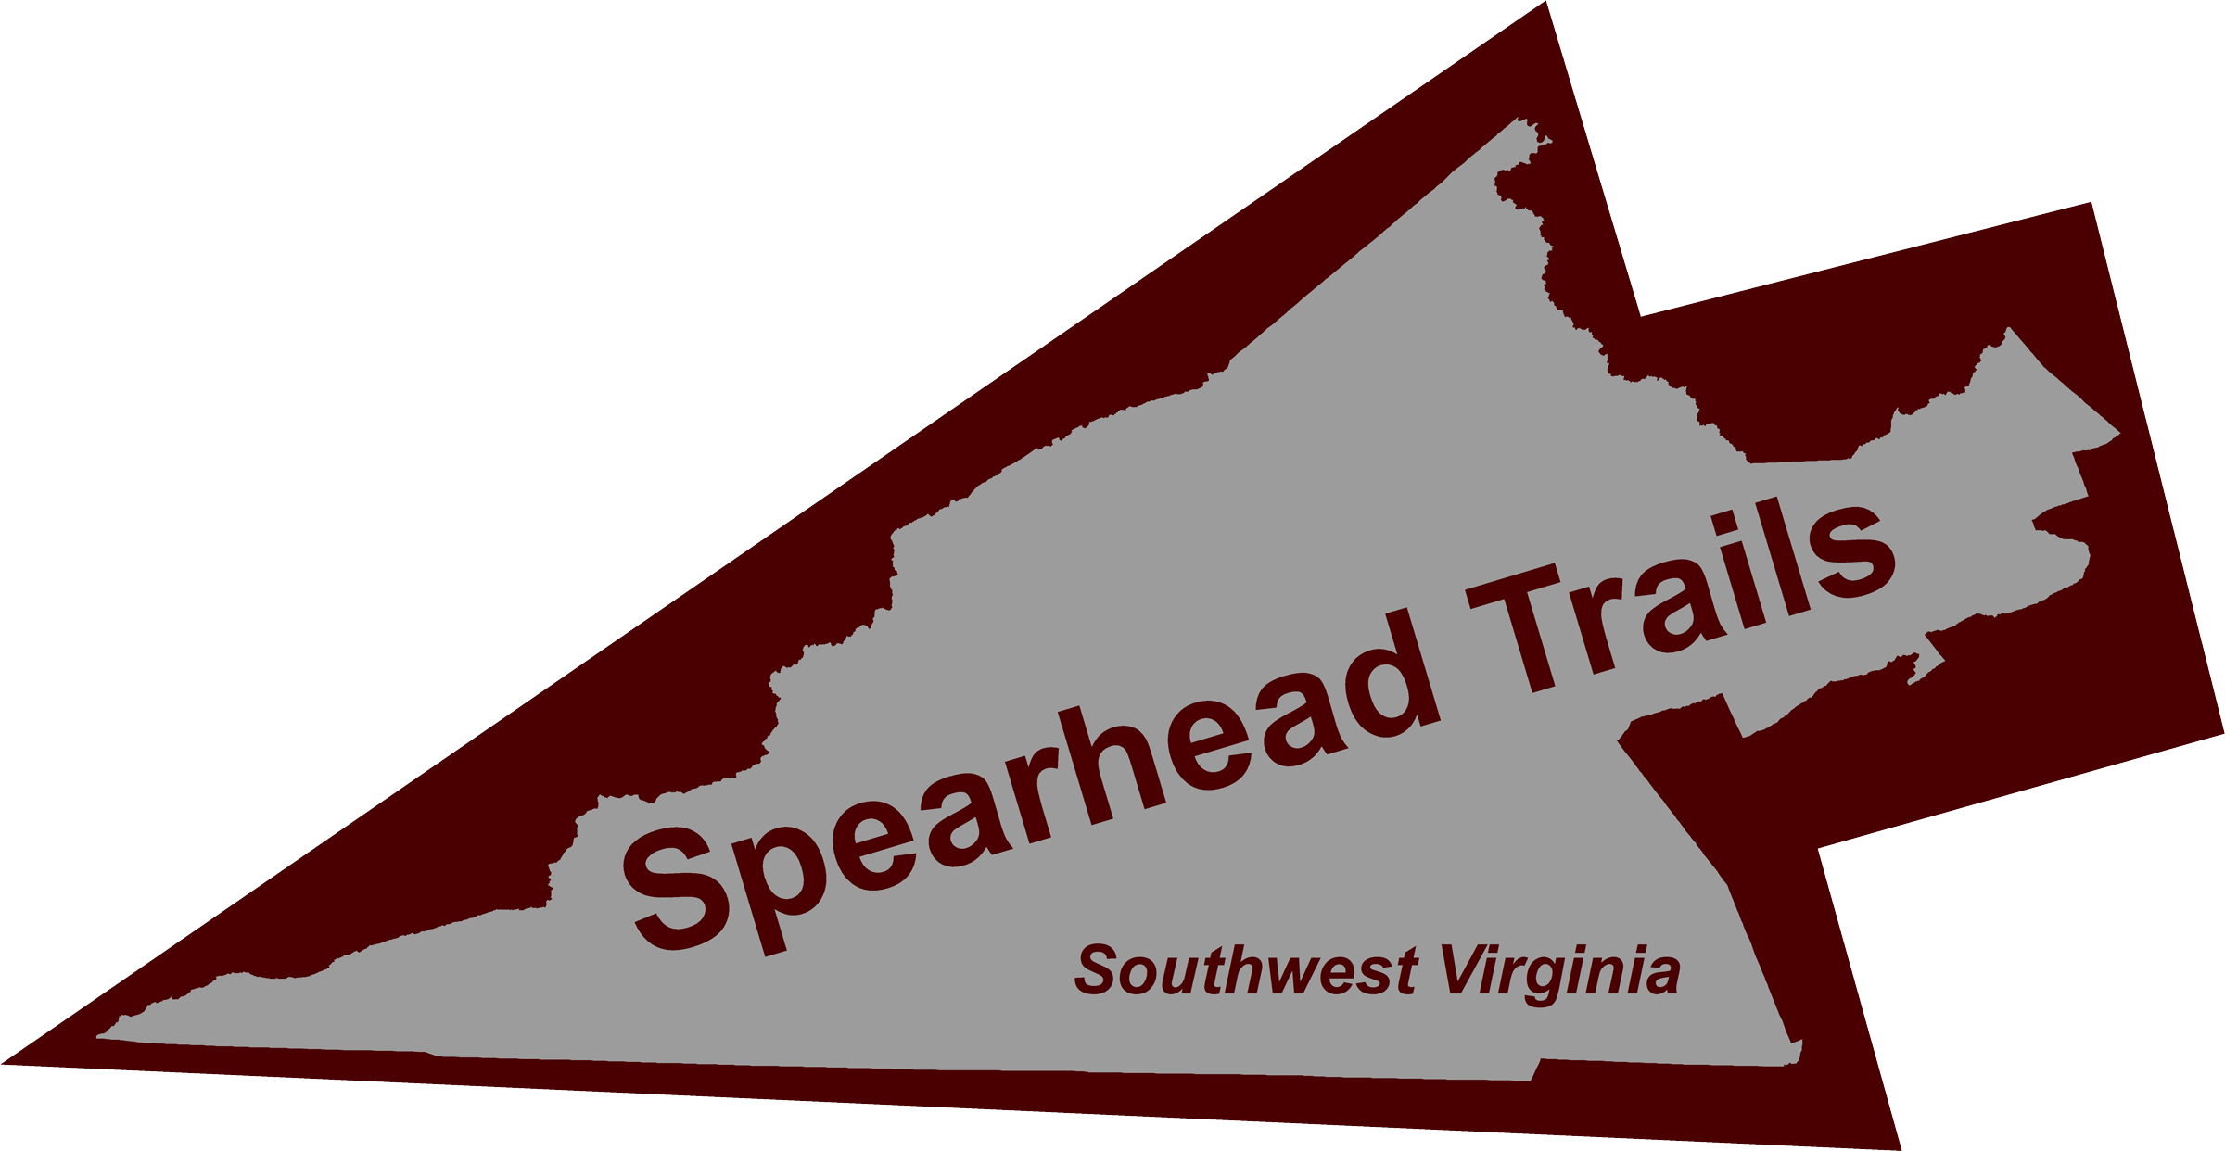
OTHER AREAS BENEFITING FROM TRAILS.
HUGE OPPORTUNITY TO CREATE 300 TO 500 NEW JOBS
AND BRING MILLIONS $ TO SOUTHWEST VIRGINIA

- The Hatfield-McCoy ATV Trail System in West Virginia established in 2000 provided an economic output of $7.7 million, created a tax revenue of $622,752; provided $2.7 million in income and created 146 new jobs according to a 2006 Economic Impact Study. Southwest Virginia already has over 100 miles of off-highway vehicle trails and has two communities declaring themselves ATV-Friendly and over 100 miles of trails

- Mountain Biking and Walking Trail: The Virginia Creeper
The total economic impact of the Virginia Creeper Trail to the State of Virginia annually is $2.5 million
with over $1.5 million dollars spent in the local economy of Washington and Grayson counties and an
estimated 27.4 jobs were created due to the increased visitors to the area.

Business tax revenues in Damascus VA have increased from $23,000 in 2003 to over $55,000
in 2009 and the year is not even over yet. Meal and lodging taxes increased from $42,000 in 2002 to $104,150 in 2008, a 60% increase in just six years. And Damascus, a town of just over 900 people has seven (7) bike rentals and shuttle services, twenty-one (21) lodging facilities within the corporate limits including an RV Park, an additional 19 lodging facilities within 2 to 17 miles of the town plus seven (7) restaurants.

There is the potential to develop similar Rails to Trails in the Spearhead Trails Region. But one does not have to have an abandoned railroad to “make this happen”. Developing stacked looped trail systems for both mountain biking and walking trails similar to the Allegrippis Trail System in Pennsylvania in any one of the seven Southwest Virginia counties has huge economic potential.

- Horseback Riding also has huge potential in Southwest Virginia especially in the Scott, Lee, Wise and Buchanan areas. Knott County Kentucky started developing horseback riding trails in their county in 2006 and hold an annual trail ride every Spring and Fall. The first year they attracted 500 riders and 250 horses. This Fall, they had over 10,000 riders and 7,000 horses come to their county for a three day event from as far away as Texas, Wisconsin and Utah. Many of the riders actually ended up staying seven days, spending on average $325 per person while in the area creating a $2.3 million dollar impact on the region. This could be happening in Southwest Virginia.

- The canoeing and boating potential in Southwest Virginia has not even begun to be tapped. My family has canoed in Kentucky, Tennessee, North Carolina, Arkansas, Utah, Montana, Colorado, Missouri and Canada. Sections of the Clinch River is better than nearly all of the rivers we have floated and is very comparable to the Meramec River in Missouri that can attract as many as 8,000 boaters on a given weekend. Restaurants, shuttle services, canoe rentals, campgrounds, hotels, cabins, outfitter stores and more have opened along its banks and within nearby communities. This could definitely be happening along the Clinch River thru Scott, Russell and Wise Counties and along the Powell River in the southern portion of Lee County.

- Virginia has one of the most extensive and complete wildlife viewing and birding trail systems in the United States that southwest Virginia has yet to capitalize on. The small town of Canadian Texas began marketing birdwatching in their community and within five years, 160 new jobs were created including 12 B&B’s, four new restaurants, the renovation of 29 commercial building of which 16 were historic structures plus a 28% increase in sales tax. All seven counties and the City of Norton have yet to capitalize on this opportunity in their communities which actually add tremendously to existing and potential trails in the area.

For more information, visit www.spearheadtrails.com.

